- Principle of Design  ____Balance ___  Justification:  Asymmetrical because part at the bottom is the same but the top isn’t  Element of Design  ______Texture______________  Justification:  Rough because it’s darker inside the pic |  |  | 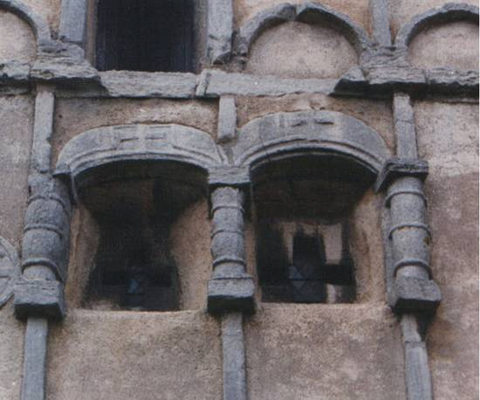
- Principle of Design  Balance  Justification: Symmetrical Because on both sides it’s the same  Element of Design  Line  Justification:  Has vertical lines represent dignity and formality like in the pic |  |  |  |  | 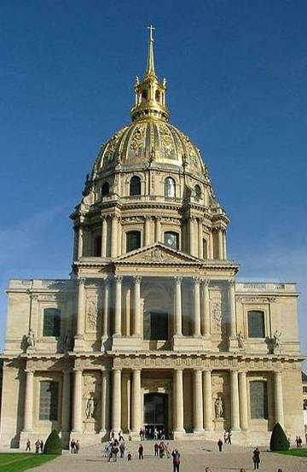
- Principle of Design  Line  Justification:  Has horizontal lines which represents peace  Element of Design  Emphasis_  Justification:  The whit color pop out of the picture comparing to the dark reddish color in the pic |  |  |  |  | 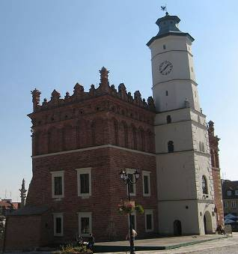
- Principle of Design  __________Balance_________  Justification:  Asymmetrical the building isn’t even  Element of Design  __________ _Line_________  Justification: Has curved lines which represents freedom or natural |  | 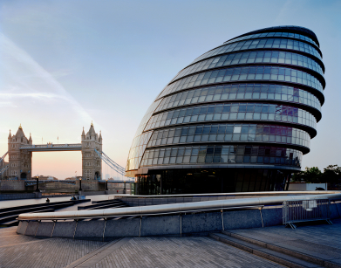  ©Istockphoto.com  City Hall and London Bridge
- Principle of Design  ____________Balance _______  Justification: Symmetrical both side are the same  Element of Design  _Color _____  Justification: Has warm colors and cool colors that complement each other | 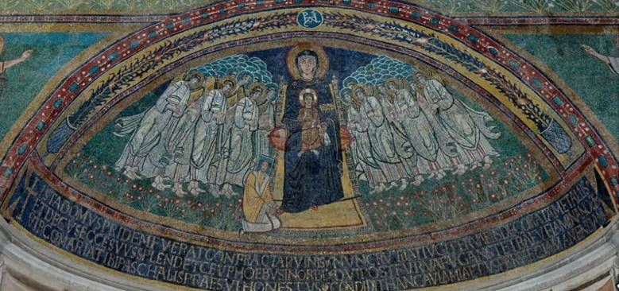
- Principle of Design  ___________Balance ________  Justification: Asymmetrical because one is higher than the other because its diagonal  Element of Design  _________Line ___________  Justification: Diagonal lines represent action or excitement |  |  |  | 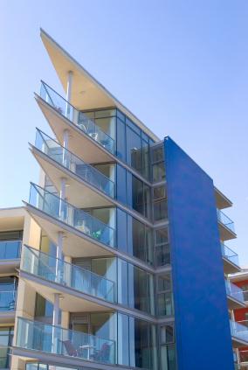  ©Istockphoto.com
- Principle of Design  Unity or Emphasis  Justification: Because it uses different colors & it brings out the pink/red  Element of Design  __________Space__________  Justification: Shows an open space going towards the house |  |  |  | 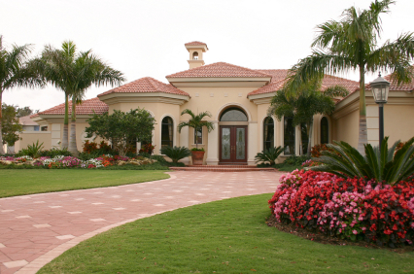  ©Istockphoto.com
- Principle of Design  Gradated rhythm ___  Justification: Tends to get smaller  Element of Design  ____Space ________________  Justification: Gets smaller shows open space |  |  | 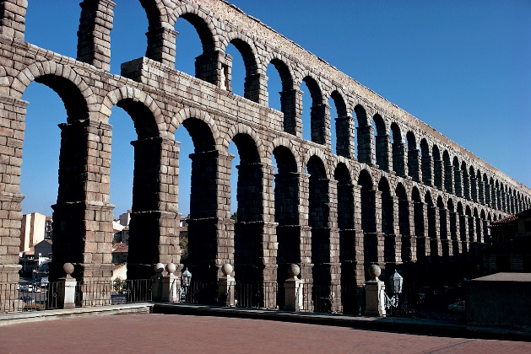  Microsoft Office clipart  Roman aqueduct
- Principle of Design  __________Balance _________  Justification: Same on both sides  Element of Design  _________Texture _  Justification: Rough texture on the inside |  |  |  | 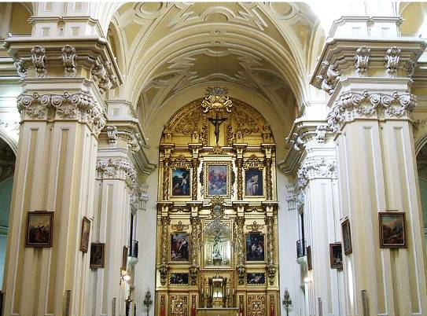
- Principle of Design  ______________Emphasis _____  Justification: Has red that pops up because the rest is blue  Element of Design  __________Line __________  Justification: Diagonal lines which represent excitement or action  Conclusion  In what way do certain elements or principles identify the time period in which a structure was created?  By the line or shape of the building also even texture  What factors might account for an incorrect identification?  It could be the way the building is built or the show of lines  Describe an example of a way that design principles and elements could impact the function of a building.  It can impact it by the colors the use to make a human feel different when going to the building or seeing it |  |  |  | 